## On Access

### Subtask 1

Gain access to the windows XP box using the exploit of your choice. Use mimikatz to acquire the hash of the password on the machine.

You should submit the following.

1. A screenshot of the hashes of the XP VM recovered through mimikatz.

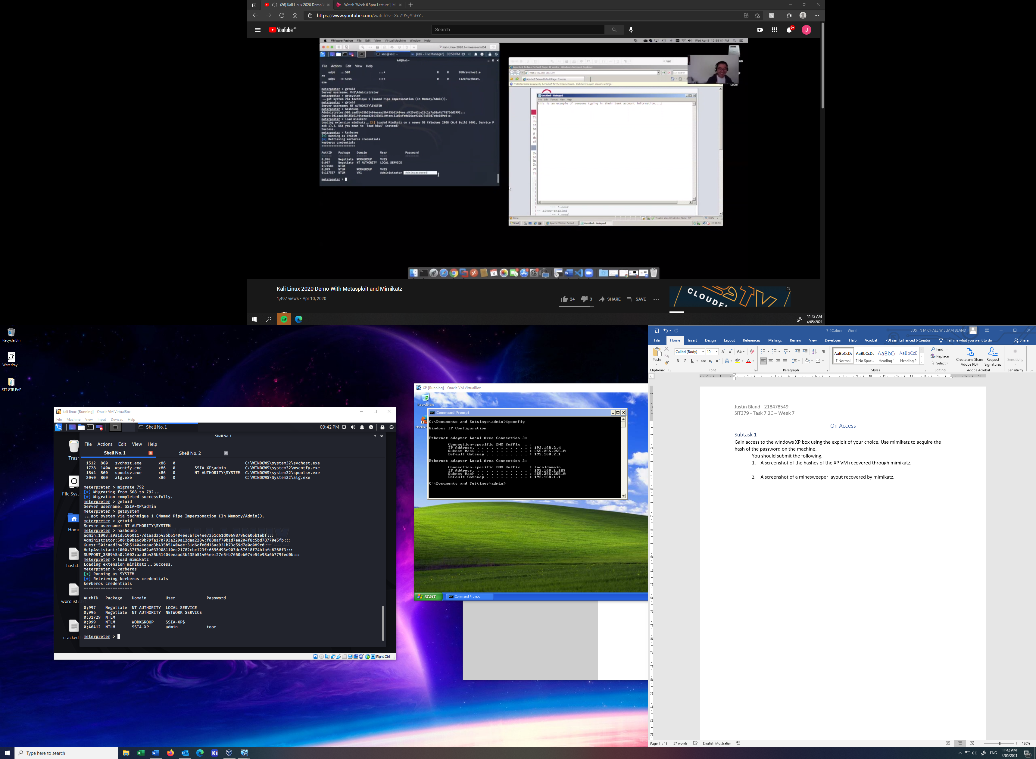

1. A screenshot of a minesweeper layout recovered by mimikatz.

